CURRICULUM VITAE
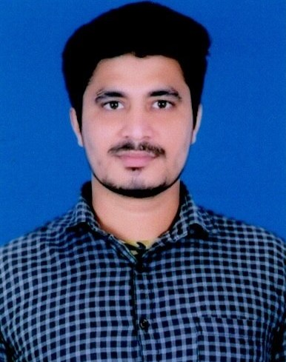
Address For Correspondence:
ASHIT KUMAR NAYAK
BHADRAK (AUTO) COLLEGE, BHADRAK
Email id:ashitkumarnayak35@gmail.com
Mob: +917008683151 (OR) 7537964659

CAREER OBJECTIVE:
I want to pursue my career in an organization of growth and excellence to meet personal and organizational goals.

Specialization: Finance (Major) and Marketing (Minor)

EDUCATIONAL QUALIFICATION:
- PG (POST GRADUATE) IN COMMERCE, 2020
- +3 Commerce, Banking and Insurance (Hons), 2017
- +2,CHSE, Odisha, 2014
- 10th, BSE, Odisha, 2012

PROJECT:
- Undertaken Two month summer internship programme (SIP) On Topic “Plan-o-gram of General Merchandise Section” at Big Bazaar.

LIVE PROJECT :
- Promote A Brand Into New Market and Maximize shareholder value

WORK EXPERIENCE :
- Financial Service Bank Mitrana
- Led a project to recognize recharge point and promote them into payment bank.
- Doing canopy activity to register customer with airtel payment bank app and sale insurance like shop insurance, bike insurance, health insurance, APY etc..

- Asst. Branch manager
- I totally operate the field work and operations of the branch.
- I have 4 Credit officer under me, I streamline their collection schedule and cheak them by surprise field visit.
- Starting personal loan 1st time in that branch.

COMPUTER PROFICIENCY: MS Office: Excel, Word, PowerPoint.

PERSONAL DETAILS:
NAME : Ashit Kumar Nayak
DOB : 11 MARCH 1997
FATHER’S NAME : Mr. Sarbeswar Nayak
MOTHER NAME : Mrs. Silubala Nayak
PERMANENT ADDRESS : At/ Po – Lunga, Ps - Basudevpur
Dist- Bhadrak, Odisha, Pin- 756124
HOBBIES : Use internet, playing volley ball and badminton
And Volunteer work.
INTERESTS : Spend time with family and friends and watching movies.
STRENGTH : Self –confidence, hard working and punctual
LANGUAGE KNOWN : Odia, Hindi and English.
Declaration:
I do here by declare that the given information furnished is correct to best of my knowledge and belief.

Date:
Place: BHADRAK (Ashit Kumar Nayak)

